Final Project Report

Web Based Gardening Care App



Project Supervisor
Haseeb Akmal

Submitted By

F24PROJECT3948D
Shahbaz Hussain Bc210401251

Software Projects & Research Section,
Department of Computer Sciences,
Virtual University of Pakistan


CERTIFICATE

This is to certify that Shahbaz Hussain (Bc210401251) have worked on and completed their Software Project at Software & Research Projects Section, Department of Computer Sciences, Virtual University of Pakistan in partial fulfillment of the requirement for the degree of BS in Computer Sciences under my guidance and supervision.

In our opinion, it is satisfactory and up to the mark and therefore fulfills the requirements of BS in Computer Sciences.

Supervisor / Internal Examiner

Haseeb Akmal
Supervisor,
Software Projects & Research Section,
Department of Computer Sciences
Virtual University of Pakistan

___________________
(Signature)

External Examiner/Subject Specialist
<<External Supervisor Name>>

___________________
(Signature)

Accepted By:

_____________
(For office use)

EXORDIUM

In the name of Allah, the Compassionate, the Merciful.

Praise be to Allah, Lord of Creation,
The Compassionate, the Merciful,
King of Judgment-day!

You alone we worship, and to You alone we pray for help,
Guide us to the straight path

The path of those who You have favored,

Not of those who have incurred Your wrath,
Nor of those who have gone astray.

DEDICATION

This Final Year Project is dedicated to
Virtual University of Pakistan
for providing me with the platform, resources, and environment to grow academically and professionally.
I extend my sincere gratitude to the university's faculty, administration, and all those who have supported and guided us throughout our journey.

ACKNOWLEDGEMENT
First and foremost, I am profoundly grateful to Almighty Allah for granting me the strength, wisdom, and perseverance to complete this project successfully.
I would like to express my sincere appreciation to Haseeb Akmal my respected project supervisor, for their continuous support, valuable guidance, and insightful feedback throughout the development of this project.
Special thanks to my family and friends for their constant encouragement, patience, and moral support during this journey.
Lastly, I acknowledge the contributions of all those who directly or indirectly helped me during various stages of this project.

PREFACE
This Final Year Project report titled "Web-based Gardening Care Application" is submitted in partial fulfillment of the requirements for the degree of [Bachelorin Computer Science] at Virtual University of Pakistan.
The project aims to address the challenges faced by home gardeners by providing a digital platform that delivers personalized plant care, community interaction, and gardening resources. It reflects the integration of theoretical knowledge with practical implementation and showcases the skills and techniques acquired during the academic program.
This document includes the detailed planning, design, development, and implementation processes of the proposed application. It also discusses the functional requirements, methodology, design models, and tools used throughout the project.
I hope this report provides valuable insight into the development of user-centric web applications and contributes meaningfully to the field of smart gardening solutions.

TABLE OF CONTENTS

CHAPTER NO. 1
gathering & Analyzing info 9

1.1 Introduction 10

1.2 purpose 10

1.3 scope 10

1.4 definitions, acronyms and abbreviations 11

1.5 use cases and usage scenarios 11

1.5.1 Use Case Diagrams 12

1.5.2 Usage Scenarios 13

1.6 supplementary requirements 13

1.6.1 Usability 13

1.6.2 Reliability 13

1.6.3 Supportability 13

1.6.4 System Requirements 13

CHAPTER NO. 2
planning the project 14
2.1 Introduction 15

2.2 Methodology 15

  - Available Methodologies 15

  - Chosen Methodology 15

  - Reasons for Chosen Methodology 15

  - Work Plan 16
  - Project Structure 16

    - Team Structure 16

    - Project Schedule (Submission Calendar) 16

CHAPTER NO. 3
designing the project 17

3.1 Introduction 18

3.2 purpose 18

3.3 scope 18

  - definitions, acronyms and abbreviations 18

  - Architectural Representation (Architecture Diagram) 19

  - Dynamic Model: Sequence Diagrams 20

  - Object Model/Logical Model: Class Diagram 21

  - Database Model (Database Diagram) 22

  - Graphical User Interfaces 23

Chapter no.4
DEvelopment 24
4.1 Development plan (Architecture Diagram) 25
4.1 Architecture Diagram 26

REFERENCES……………………………………………………………27
PREFACE………………………………………………………………....28

CHAPTER 1
Gathering & Analyzing Info

CHAPTER NO. 1

GATHERING & ANALYZING INFORMATION

1.1 INTRODUCTION
The "Web-based Gardening Care Application" is designed to offer a smart, user-friendly platform to support and guide home gardeners in their day-to-day gardening tasks. The application addresses various gardening challenges by providing personalized care recommendations, plant tracking features, educational resources, and community-based interaction. This chapter elaborates on the purpose, scope, user requirements, and initial design approaches used in the development process.
1.2 PURPOSE
The primary purpose of this application is to assist home gardeners in improving plant care through a digital platform that combines plant data, location-based recommendations, and a community forum. By integrating weather forecasts, plant care tips, and task reminders, the app aims to simplify gardening for users of all experience levels.
1.3 SCOPE
The application will cater to the following user roles:
- Home Owners: Track plant growth and receive care recommendations.
- Gardeners: Manage plant information and monitor plant health.
- Supervisors: Oversee gardener activities and plant status.
- System Admins: Manage users and maintain the application.
Key features include:
- User registration and profile management
- Comprehensive plant database
- Personalized plant care recommendations
- Plant tracking and monitoring
- Alerts and notifications
- Integration with external services (e.g., weather APIs)
- Community features via social platforms

1.4 DEFINITIONS, ACRONYMS AND ABBREVIATIONS
- UI: User Interface
- API: Application Programming Interface
- DBMS: Database Management System
- CRUD: Create, Read, Update, Delete
- FYP: Final Year Project
- UX: User Experience
- GPS: Global Positioning System
1.5 USE CASES AND USAGE SCENARIOS
1.5.1 Use Case Diagrams
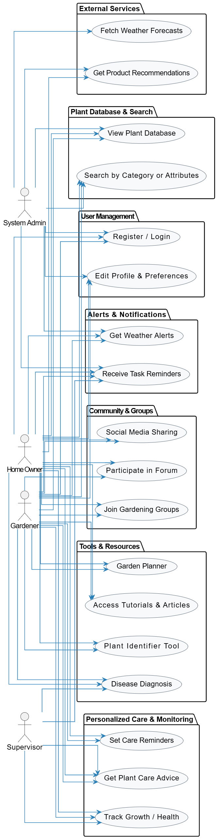
1.5.2 Usage Scenarios
- A home owner logs in, enters their location and soil type, and receives tailored care instructions.
- A gardener updates the growth status of a plant and sets a reminder for the next watering session.
- A supervisor reviews plant health data and assigns tasks to the gardener.
1.6 SUPPLEMENTARY REQUIREMENTS
1.6.1 Usability
- The application should be user-friendly and intuitive for users of all technical backgrounds.
- Interfaces should be responsive and accessible across multiple devices.
1.6.2 Reliability
- The application must ensure data integrity and high availability.
- System uptime must be maintained at 99% or higher.
1.6.3 Supportability
- The system should be easily maintainable with clear documentation.
- Future features or modules can be integrated without significant architectural changes.

1.6.4 System Requirements
- Frontend: React.js with HTML, CSS, and JavaScript
- Backend: Node.js with Express
- Database: MongoDb
- External APIs: Weather API, GPS location
- Hosting: Cloud-based platform like AWS or Firebase

CHAPTER 2
Planning the Project

CHAPTER NO. 2

PLANNING THE PROJECT

2.1 INTRODUCTION
Planning is a critical phase in the software development lifecycle. It involves selecting the appropriate methodologies, preparing a realistic work plan, and structuring the project for effective team collaboration. This chapter outlines the approach taken for planning the Gardening Care Application.
2.2 METHODOLOGY
A structured methodology is essential to guide the project through its development lifecycle. The methodology determines how requirements are gathered, how designs are implemented, and how the system is tested and maintained.
2.3 AVAILABLE METHODOLOGIES
Some of the commonly used software development methodologies include:
- Waterfall Model
- Agile Methodology
- Spiral Model
- Iterative Development
- V-Model
2.4 CHOSEN METHODOLOGY
Agile methodology was selected for this project due to its iterative approach, flexibility, and focus on continuous feedback. Agile is well-suited for projects where requirements may evolve during the development phase.
2.5 REASONS FOR CHOSEN METHODOLOGY
- Enables continuous user feedback and refinement
- Allows for adaptive planning and evolutionary development
- Provides flexibility to incorporate changes at any stage
- Encourages collaboration among cross-functional teams

2.6 WORK PLAN
The development process was broken into weekly sprints, each focusing on specific deliverables such as requirements gathering, design, frontend/backend development, integration, and testing. The work plan ensures timely progress tracking and accountability.
2.7 PROJECT STRUCTURE

2.7.1 Team Structure
- Project Supervisor: Oversees project direction and academic alignment
- Team Lead: Responsible for task delegation and milestone tracking
- Frontend Developer: Designs and implements UI components
- Backend Developer: Builds APIs and handles database operations
- Tester: Performs functional and performance testing
2.7.2 Project Schedule (Submission Calendar)
- Week 1-2: Requirement Gathering and Analysis
- Week 3-4: Project Planning and Tool Setup
- Week 5-6: Frontend and Backend Design
- Week 7-8: Core Feature Development (User Management, Plant DB)
- Week 9-10: Advanced Features (Recommendations, Alerts)
- Week 11: Testing and Debugging
- Week 12: Documentation and Final Presentation

CHAPTER 3
Designing the Project

CHAPTER NO. 3
DESIGNING THE PROJECT

3.1 INTRODUCTION
This chapter presents the design components of the Gardening Care Application, including architectural diagrams, sequence diagrams, class models, and database schema. It also outlines the user interface prototypes developed during the design phase.
3.2 PURPOSE
The purpose of this chapter is to document the system design and visualize its internal structure and behaviour. It helps developers, testers, and stakeholders understand the core components and their interactions.
3.3 SCOPE
The design documents all aspects of the application including architecture, data flow, UI layout, and entity relationships. It ensures a clear understanding of system operations before development.
3.4 DEFINITIONS, ACRONYMS AND ABBREVIATIONS
- UI: User Interface
- API: Application Programming Interface
- DBMS: Database Management System
- CRUD: Create, Read, Update, Delete
- FYP: Final Year Project
- UX: User Experience
3.5 ARCHITECTURAL REPRESENTATION (ARCHITECTURE DIAGRAM)
The application follows a client-server architecture with the following layers:
- Presentation Layer: React frontend for user interaction
- Business Logic Layer: Node.js and Express.js APIs for processing
- Data Layer: MongoDB database for persistent storage (Include architecture diagram in Appendix/Diagrams section)
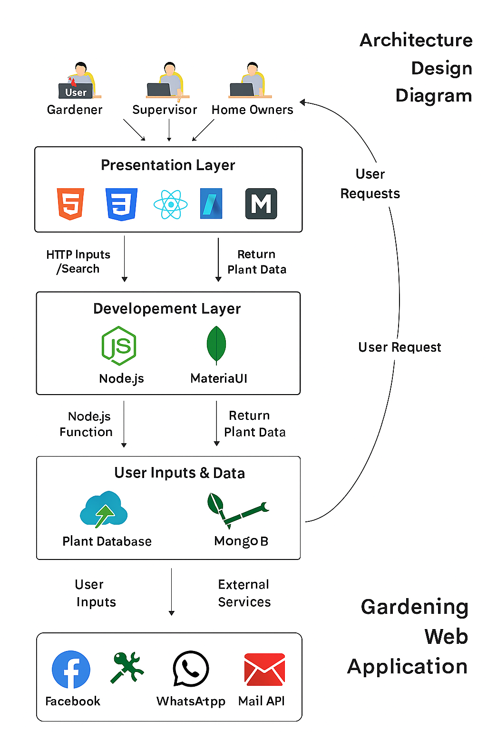
3.6 DYNAMIC MODEL: SEQUENCE DIAGRAM
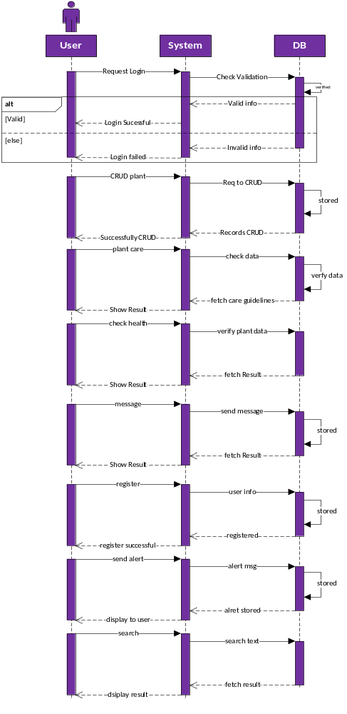

3.7 OBJECT MODEL/LOGICAL MODEL: CLASS DIAGRAM:

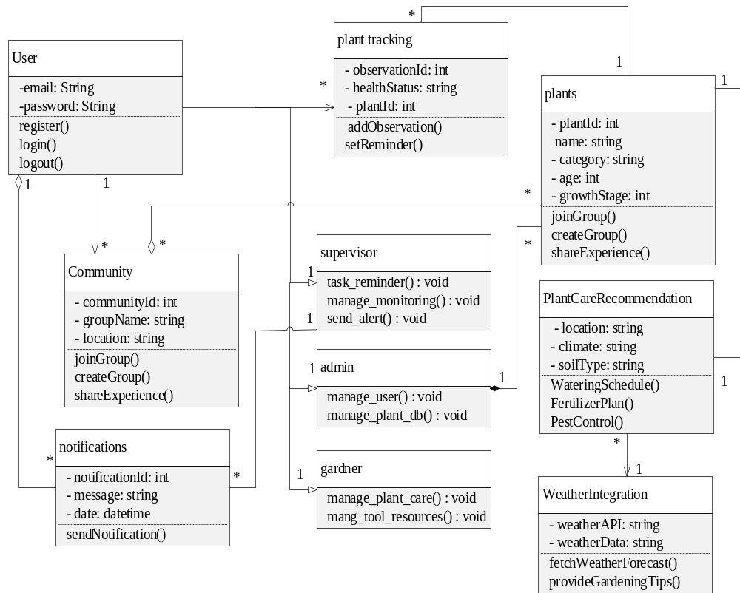

3.8 DATABASE MODEL (DATABASE DIAGRAM):

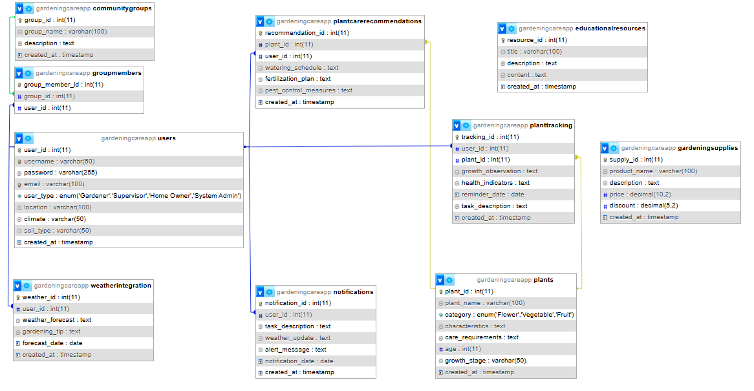
3.9 GRAPHICAL USER INTERFACES
Login:
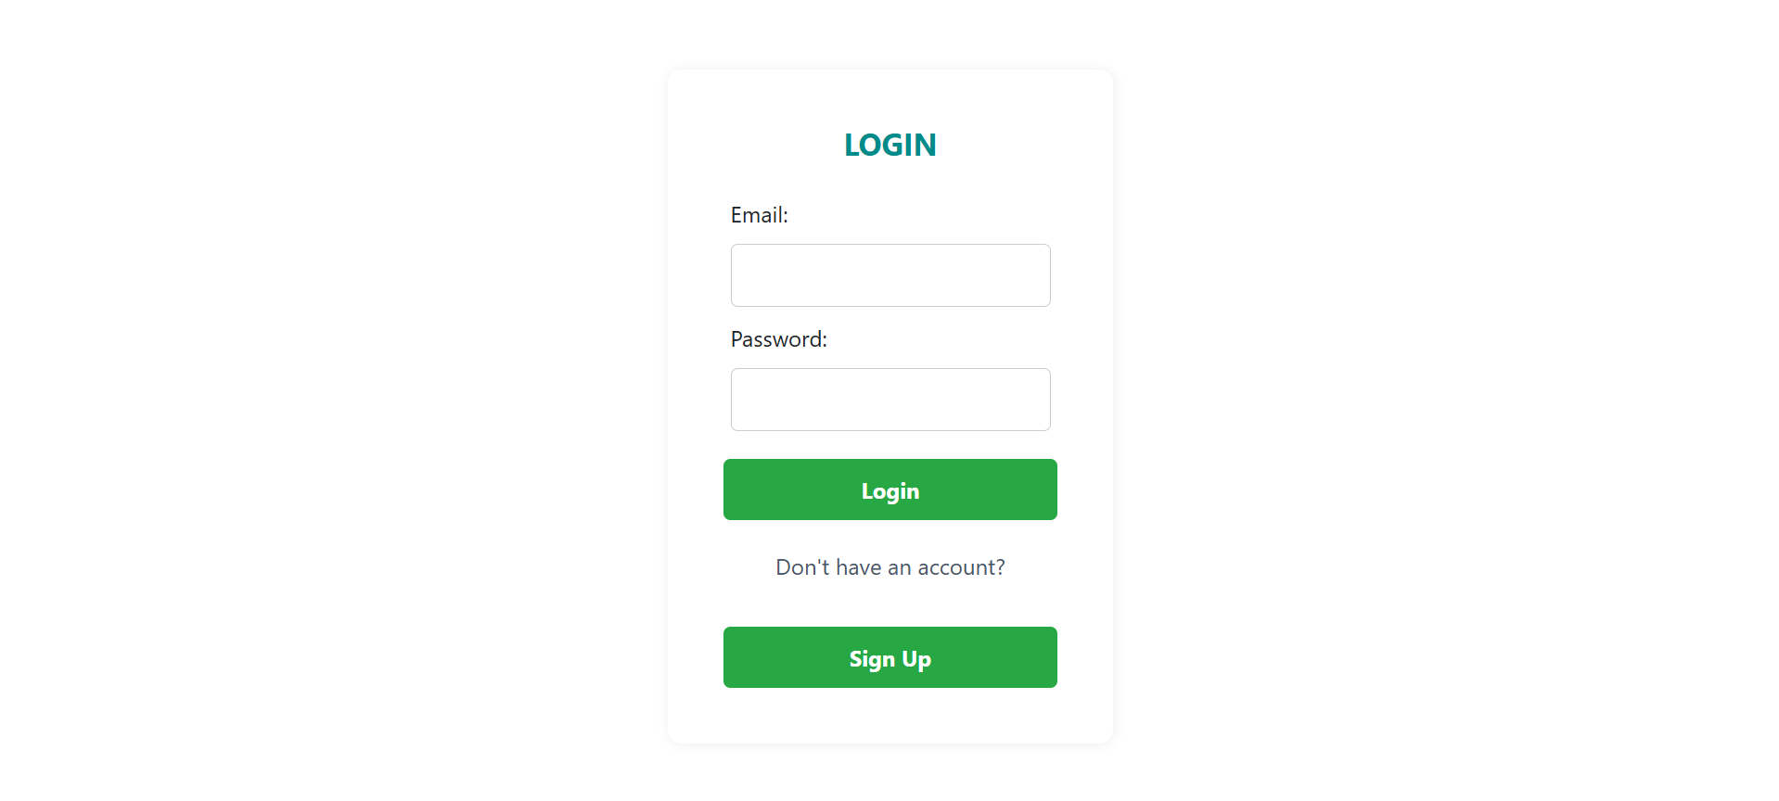
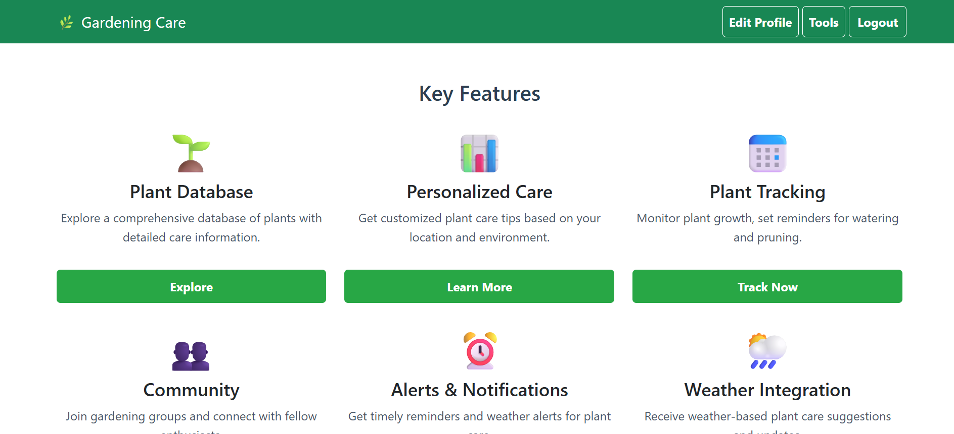

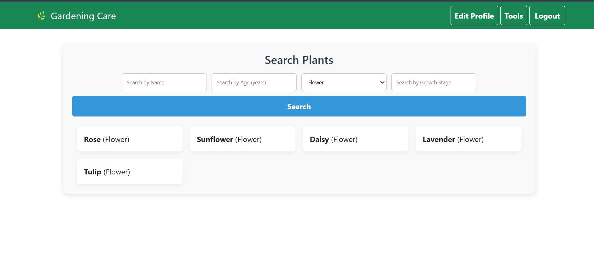

CHAPTER 4
Development

CHAPTER NO. 4
DEVELOPMENT

4.1 DEVELOPMENT PLAN (ARCHITECTURE DIAGRAM)
The Gardening Care Application development followed the modular architecture defined during the design phase. This structure helped in parallel development and integration of individual components. The development plan includes:
- Frontend Development
Technologies used: React.js, HTML, CSS, Bootstrap
Components Developed:
  - Login/Register Forms
  - Plant Listing and Details
  - Care Recommendation Cards
  - Alert/Notification UI
  - User Dashboards
- Backend Development
Technologies used: Node.js, Express.js
Modules Developed:
  - User Authentication & Authorization
  - Plant Data Management
  - Recommendation System based on user inputs
  - Notification System
  - Integration with external Weather API
- Database Development
Technologies used: MongoDB
Collections Designed:
  - Users
  - Plants
  - CareTips
  - Reminders
  - WeatherData
  - Messages/Community Threads
- Integration and Testing
  - Integration of backend APIs with frontend
  - Functional testing of modules
  - User Acceptance Testing (UAT)
  - Bug Fixes and Refinements

ARCHITECTURE DIAGRAM:

REFERENCES

In order to develop our system, we have referenced a number of different sources. We have taken help from these sources for resolving technical issues and to make our system more efficient and user-friendly. However, the major sources were:
• Web Development with Node and Express (by Ethan Brown)
This book helped us understand backend development using Express.js, including routing, middleware, and building RESTful APIs.
• React – The Complete Guide (by Maximilian Schwarzmüller)
This course was extremely useful in understanding React components, props, state management, and implementing frontend logic in our application.
• W3Schools (https://www.w3schools.com)
This website helped us in learning the basic structure and usage of HTML, CSS, and JavaScript. It also supported us in styling the interface using Bootstrap and writing cleaner code.
• MongoDB Documentation (https://www.mongodb.com/docs/)
We used official MongoDB documentation to understand how to structure, query, and manage our NoSQL database efficiently using Mongoose.
• OpenWeatherMap API Documentation (https://openweathermap.org/api)
This was the main source for integrating weather forecast features into our gardening app and understanding how to handle API responses.
• Plant.id API Documentation (https://web.plant.id/plant-identification-api/)
We referenced this site to implement the plant identification feature and understand how to process images and interpret health diagnostics.
• Software Engineering I & II (by Fakhar Lodhi)
These handouts were referenced for software design principles, testing strategies, and development lifecycle to maintain quality and structure in our project.

APPENDIX

Section 1 | Gathering & Analyzing Info
Section 2 | Designing the Project
Section 3 | Development

